Exit Counseling Instructions

In accordance with federal regulations, each student that graduates from, withdraws from or no longer attends Point University and received student loans to fund his/her education must complete Federal Student Loan Exit Counseling. Please follow the steps below to complete your Exit Counseling.

Step 1: Go to www.studentloans.gov .

Step 2: Sign in to the website.
*You will need your Federal PIN (the 4-digit number used to sign the FAFSA) to sign in
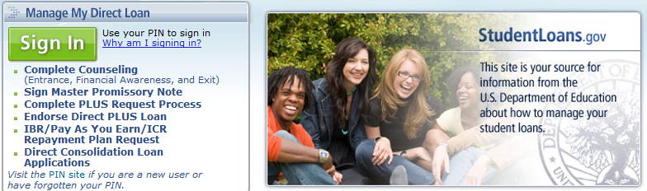

Step 3: Select Complete Counseling.

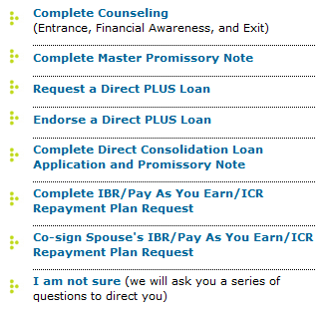

Step 4: Select Start in the Exit Counseling box and follow the instructions to complete the documentation. Please note that you may need to select Atlanta Christian College (our former name) to complete the documentation and have it sent to us.

