*FIRST CHRISTIAN CHURCH*

*WATER VALLEY*

*MISSISSIPPI*

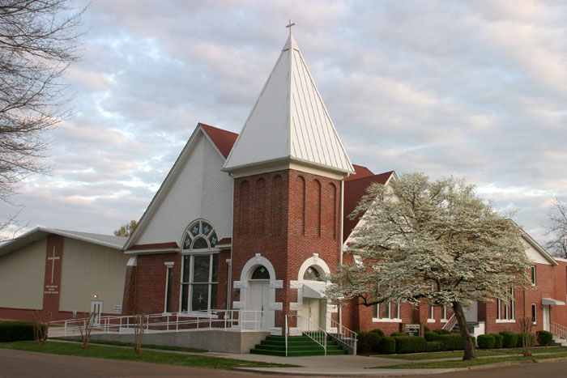

Vacancy Announcement

Senior Pastor Position

First Christian Church is seeking candidates for the position of senior pastor. The church is located in rural Northwest Mississippi approximately 85 miles south of Memphis, Tennessee and 20 miles south of Oxford, Mississippi, and the University of Mississippi. The church was founded over 100 years ago making it one of the earliest Independent Christian Churches in the state. Our rule of faith is the New Testament. We believe both the Old and New Testament are inspired by God, but the New Testament is the exclusive book of authority today. We believe salvation is given by the grace of God after one accepts Jesus as the Savior and Lord of one’s life by faith. We accept Jesus by **believing** in Him as Lord and Savior, **repenting** of our sins, making **confession** of Him, and being **baptized** into Him. We practice baptism by immersion. You may refer to our web site [www.wvchristian.org](http://www.wvchristian.org) and our Facebook page Water valley Christian Church for additional information about the church.

**Duties and Responsibilities:**

• Preach and teach the gospel.

• Shepherding the congregation exercising a concern for the spiritual needs of the church.

• Visit the sick, shut-ins and prospective members.

• Attend monthly board meeting and report on past and future activities.

• All other duties as mutually agreed to by the pastor and church board.

**Knowledge, Skills, and Abilities:**

• PREACHING: Seek to discern God’s message for the congregation.

• VISION CASTING: Seek God’s direction and develop His vision for the church in a way that

maximizes the gifts and resources available.

• COOPERATION: Exhibit strong diplomatic skills and be accountable to the Church Board.

• CONGREGATION LEADERSHIP: Exhibit a passion for ministry and lead by example.

• RELATIONAL: Work with Church Board, staff, volunteers, and the

congregation as a whole.

• PRAYER: Seek and promote prayer as a priority, both personally and in

the life of the church

• EVALUATION/DEVELOPMENT: Continually evaluate the effectiveness of programs and propose

creative ideas for improvement.

• BUDGET: Participate in the planning of the church budget in cooperation with the Church Board

• TECHNOLOGY: Possess current technology skills

**Spiritual Qualifications:**

• A deep, personal relationship with Jesus Christ evidenced in daily life and exhibiting character

qualities outlined in 1 Timothy 3:1 – 7, Titus 1:5 – 9, and 1 Peter 5:1 – 4.

• Exhibit personal qualities that are of the highest integrity and unquestionable honesty.

• Earnestly seek God’s will above all other possible motivations.

• Excellent communicator; visionary leader

• Endorse, support, and effectively communicate the vision of Christ’s Church

• Possess a peaceful spirit of cooperation and fellowship within the church body.

• Demonstrate a passionate, heartfelt love for people with a Christ-like concern for their spiritual,

physical, mental, and emotional well-being.

• Exhibit Christ’s love by developing positive and encouraging relationships within the church

body and in the community.

**Education and Experience:**

• Minimum of a Bachelor-level degree from an accredited Christian College (Preferred)

• Ordained minister of the Christian Church

• Experience in preaching ministry preferred.

**Salary**

To be determined by the church board based on degree and years of experience.

**For more information or to submit a resume write, call or email:**

**First Christian Church P.O. Box 90 Jerry Holt (662) 473-8223**

**Water Valley, MS 38965 wvsd2@hotmail.com**